Analysis of the game

Each item has a certain cost and increases the particular stats. An important thing is to see the correspondence between the items and stats. We have created the following data table which will be on a great help for the research of the game.
Also I have analyzed several sources which include some statistics of the battle results. What is important is that that we have analyzed the particular item and see the

Item | cost, gold | win rate, %
Hunter's Machete+ | 300 | 42,08
Amplifying Tome | 435 | 46,07
Augment: Death | 1000 | 51,81
B. F. Sword | 1550 | 51,62
Blasting Wand | 860 | 45,16
Bonetooth Necklace+ | 800 | 16,02
Boots of Mobility | 1000 | 55,58
Boots of Speed | 325 | 40,5
Boots of Swiftness+ | 1000 | 54,66
Brawler's Gloves | 400 | 46,07
Chain Vest | 720 | 46,72
Cloak of Agility | 730 | 44,61
Cloth Armor | 300 | 43,68
Dagger | 400 | 42,42
Faerie Charm | 180 | 41,93
Fiendish Codex | 820 | 44,91
Giant's Belt | 1000 | 48,38
Health Potion | 35 | 40,07
Last Whisper | 2300 | 58,78
Long sword | 360 | 45,62
Mana Potion | 35 | 40,77
Needlessly Large Rod | 1600 | 56,85
Negatron Cloak | 720 | 44,56
Ninja Tabi | 1000 | 50,4
Null-Magic Mantle | 400 | 44,31
Pickaxe | 875 | 46,07
Quicksilver Sash+ | 1550 | 46,75
Rabadon's Deathcap | 3300 | 58,05
Recurve Bow | 900 | 51,88
Rejuvenation Bead | 180 | 37,11
Ruby Crystal | 475 | 43,01
Ruby Sightstone+ | 1550 | 55,2
Runaan's Hurricane (Ranged Only) | 2400 | 56,93
Sapphire Crystal | 400 | 46,23
Sightstone+ | 950 | 46,46
Sorcerer's Shoes | 1100 | 52,53
Spirit Stone | 700 | 43,82
Sword of the Divine+ | 2150 | 55,31
The Hex Core | spec | 27,18
Warden's Mail+ | 1000 | 48,06
Abyssal Scepter+ | 2560 | 55,95
Aegis of the legion+ | 1950 | 54,59
Avarice blade | 800 | 45,73
Banner of command+ | 2400 | 57,72
Berserker's Greaves | 900 | 50,52
Bilgewater Cutlass | 1400 | 42,5
Catalyst the Protector | 1200 | 39,1
Chalice of Harmony | 880 | 46,07
Crystalline Flask+ | 345 | 48,46
Deathfire Grasp+ | 3100 | 56,04
Elixir of Brilliance | 250 | 47,88
Elixir of Fortitude | 350 | 48,86
Executioner's Calling+ | 1900 | 50,11
Frozen mallet | 3300 | 54,14
Guardian Angel | 2750 | 59,95
Guardian's Horn+ | 1025
Haunting Guise+ | 1485 | 48,47
Hexdrinker | 1350 | 48,02
Hextech Revolver | 1200 | 46,02
Ichor of Rage | 500
Ionian Boots of Lucidity | 1000 | 54,1
Kindlegem | 850 | 48,64
Liandry's Torment+ | 2900 | 57,82
Maw of Malmortius | 3200 | 56,38
Mejai's Soulstealer | 1235 | 62,01
Mercurial Scimitar+ | 3700 | 55,8
Mercury's Treads+ | 1200 | 52,47
Mikael's Crucible+ | 1600 | 59,58
Ohmwrecker+ | 2000 | 57,72
Overlord's Bloodmail | 2455 | 57,15
Randuin's Omen+ | 3000 | 56,26
Rylai's Crystal Scepter+ | 2900 | 56,25
Sanguine Blade | 2275 | 56,37
Seeker's Armguard | 1160 | 46,69
Sheen+ | 1200 | 48,06
Stinger | 1250 | 50,45
Sunfire Cape+ | 2650 | 56,75
Sword of the Occult | 1200 | 64,06
Targon's Brace+ | 850 | 42,28
Tear of the Goddess | 700 | 53,26
The Bloodthirster | 3200 | 55,49
Thornmail | 2200 | 51,78
Tiamat (Melee Only)+ | 1900 | 54,33
Vampiric Scepter | 800 | 41,34
Void Staff | 2295 | 57,53
Warmog's Armor | 2830 | 55,27
Wicked Hatchet | 1200
Wooglet's Witchcap+ | 3500 | 58,49
Zeke's Herald+ | 2450 | 53,98
Zhonya's Hourglass+ | 3260 | 58,16
Ancient coin | 365
Archangel's Staff | 2700 | 51,91
Atma's Impaler | 2300 | 58,93
Augment: Power | 1000 | 48,71
Banshee's Veil | 2750 | 54,86
Blackfire Torch | 2650 | 58,51
Blade of the Ruined King | 3200 | 54,97
Doran's Blade | 440 | 46,83
Doran's Ring | 400 | 46,09
Doran's Shield | 440 | 48,17
Entropy+ | 2700
Frost Queen's Claim+ | 2000 | 54,99
Frostfang | 850 | 47,53
Frozen Heart+ | 2900 | 57,82
Glacial Shroud | 1350 | 50,66
Grez's Spectral Lantern+ | 1350 | 47,15
Hextech Gunblade+ | 3400 | 54,54
Hextech Sweeper+ | 2000 | 55
Ichor of Illumination | 500
Infinity Edge | 3800 | 58,43
Locket of the Iron Solari+ | 2550 | 57,49
Lord Van Damm's Pillager | 3800 | 57,49
Madred's Razors | 700 | 48,46
Manamune | 2100 | 50,82
Moonflair Spellblade+ | 2600
Morellonomicon+ | 2200 | 53,66
Muramana | spec | 56,78
Nashor's Tooth | 2920 | 55,54
Nomad's Medallion | 850 | 48
Odyn's Veil+ | 2520
Orb of Winter | 2080
Phage | 1325 | 44,05
Phantom Dancer+ | 2800 | 57,04
Prospector's Blade | 950
Prospector's Ring | 950
Ravenous Hydra (Melee Only)+ | 3300 | 57,18
Relic Shield+ | 365
Rod of Ages | 2800 | 53,52
Seraph's Embrace+ | spec | 55,42
Spectre's Cowl | 1400
Spellthief's Edge | 365
Spirit of the Ancient Golem+ | 2000 | 53,79
Spirit of the Elder Lizard+ | 2000 | 57,05
Spirit of the Spectral Wraith+ | 2000 | 53,8
Statikk Shiv+ | 2500 | 56,69
The Brutalizer | 1337 | 45,57
Twin Shadows 1 + | 2000 | 58,86
Twin Shadows 2 + | 1800 | 58,86
Wit's End | 2400 | 57,16
Zeal | 1175 | 47,24
Athene's Unholy Grail | 2600 | 54,31
Augment: Gravity | 1000 | 44,99
Face of the Mountain+ | 2000
Guinsoo's Rageblade | 2600 | 56,8
Lich Bane+ | 3000 | 55,88
Talisman of Ascension+ | 2000 | 56,89
The Black Cleaver+ | 3000 | 56,38
The Lightbringer+ | 2200 | 54,93
Will of the Ancients | 2000 | 56
Youmuu's Ghostblade+ | 2700 | 55,29
Zephyr+ | 2850 | 60,05
Iceborn Gauntlet+ | 3250 | 59,42
Spirit Visage | 2750 | 55,67
Trinity Force | 3703 | 58,15
Wriggle's Lantern+ | 1650 | 49,26

The main source of this statistics is

Items statistic http://www.elophant.com/league-of-legends/items/win-rate?region=all&tier=all&period=all
Items database http://gameinfo.eune.leagueoflegends.com/en/game-info/items/

Since the results are taken from different sources, and the statistics were taken from different time periods, I’m planning to find the weighted sum of the results:

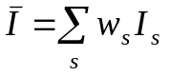, (1)

Where the weighting coefficients were calculated according the following principle. If the particular source gives the info using the longer period of time, the results are more reliable. Therefore, one can use larger value of weighting coefficient. All weighting coefficients are normalized according to the following principle

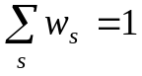 (2)

Considered info and battle results will help to estimate the utilities and build the game models.

One of the results I have obtained is the histogram which describes the number of items which increase the particular stat.
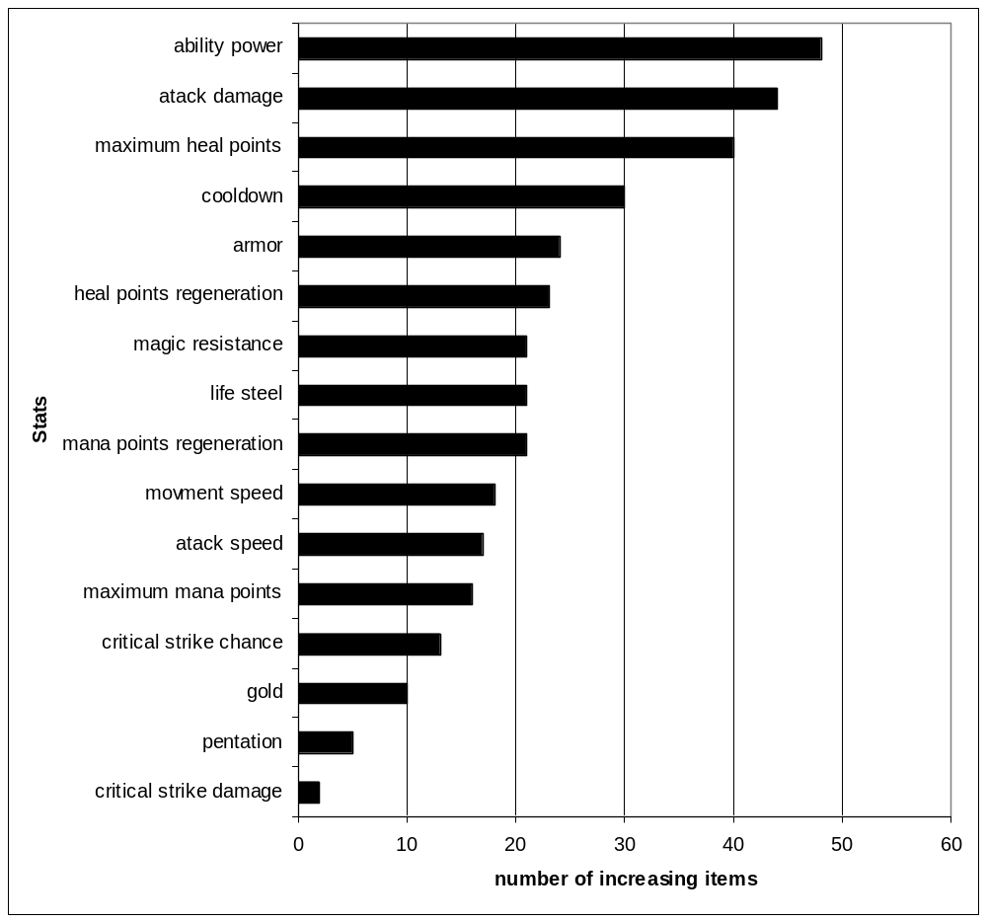
Fig. 1. Items&Stats historgram

One can see, for instance, that the critical strike damage can be increased only ny 3 items and so on. This info will be used in future model devepment as well.

